Installation On computers with only UEFI support
user: sherline password: sherline
The Unified Extensible Firmware Interface (UEFI) is a specification that defines a software interface between an operating system and platform firmware. UEFI replaces the Basic Input/Output System (BIOS) firmware interface.

1.- Boot with the DVD.
2.-Select “Install Ubuntu 12.04-UEFI-18.7.10” then press enter
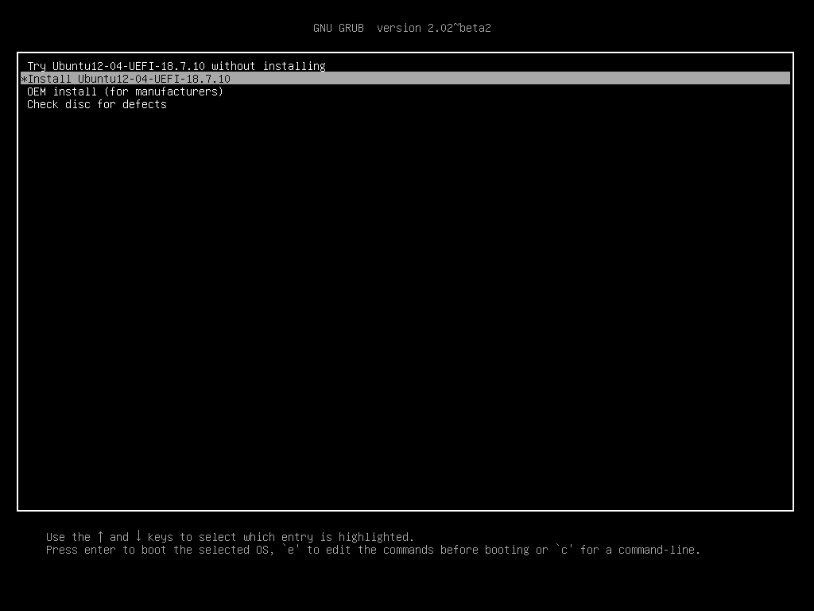

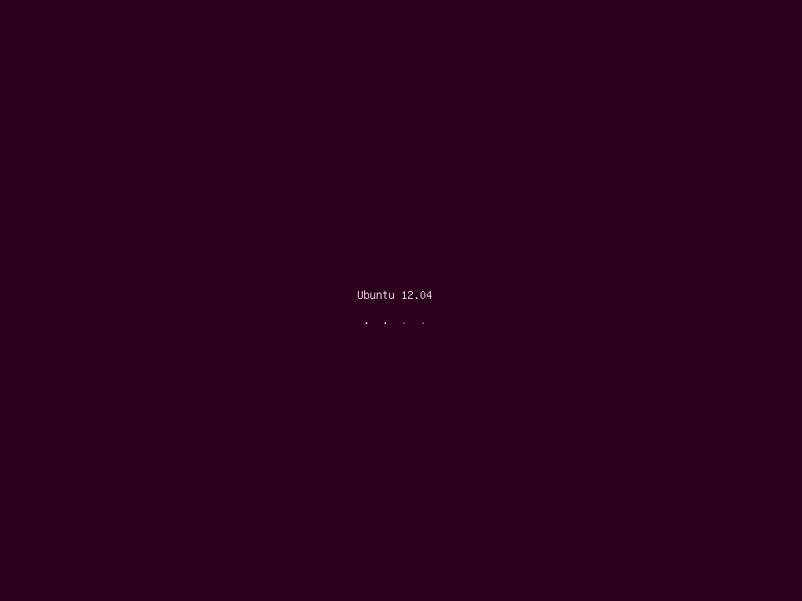

3. Select Language then Click on “Continue”
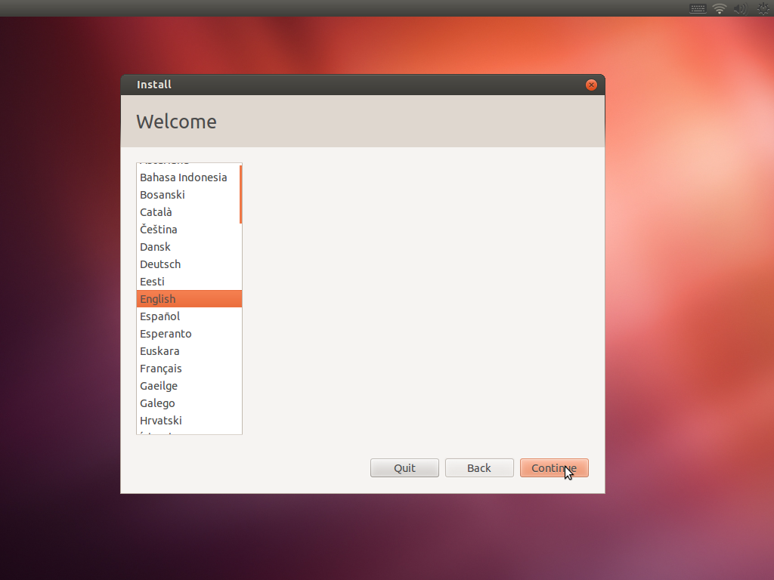

4.-Click on “Continue”
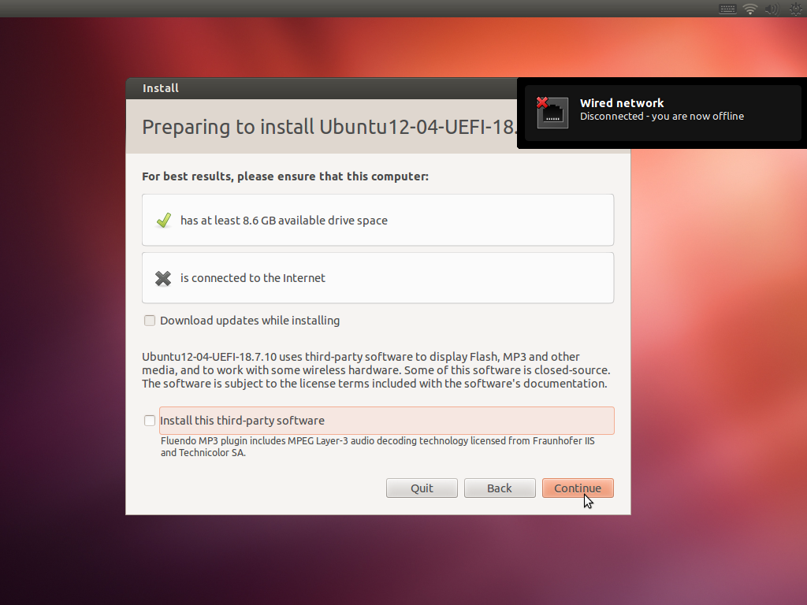

5.- Select “Something else” and click on Continue.
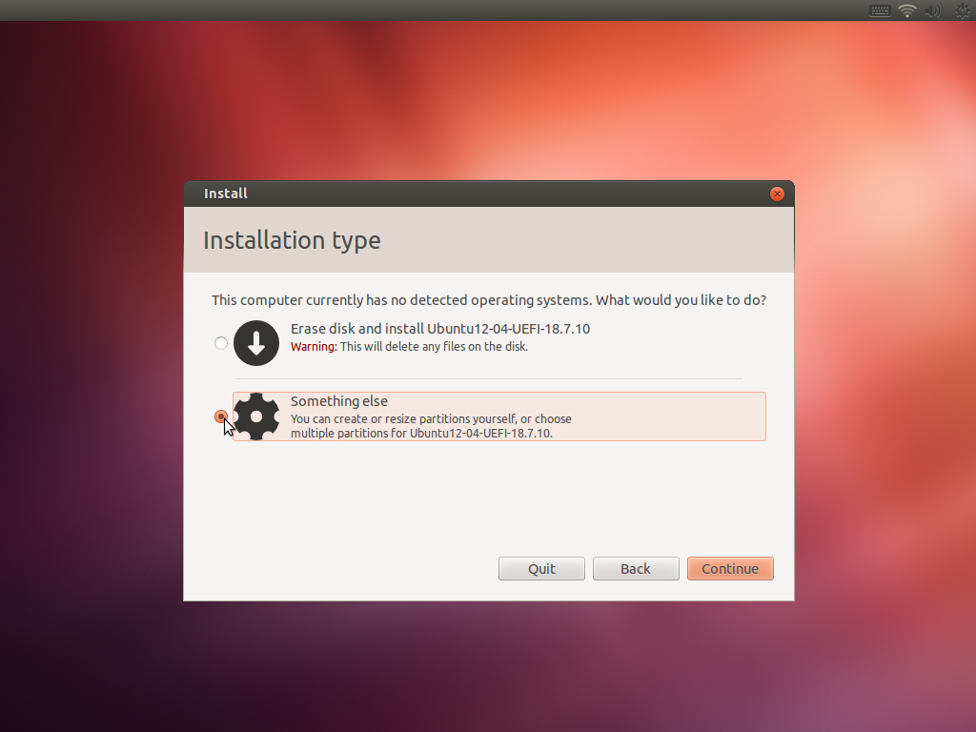

6.-Select “/dev/sda” and click on “New partition table”.
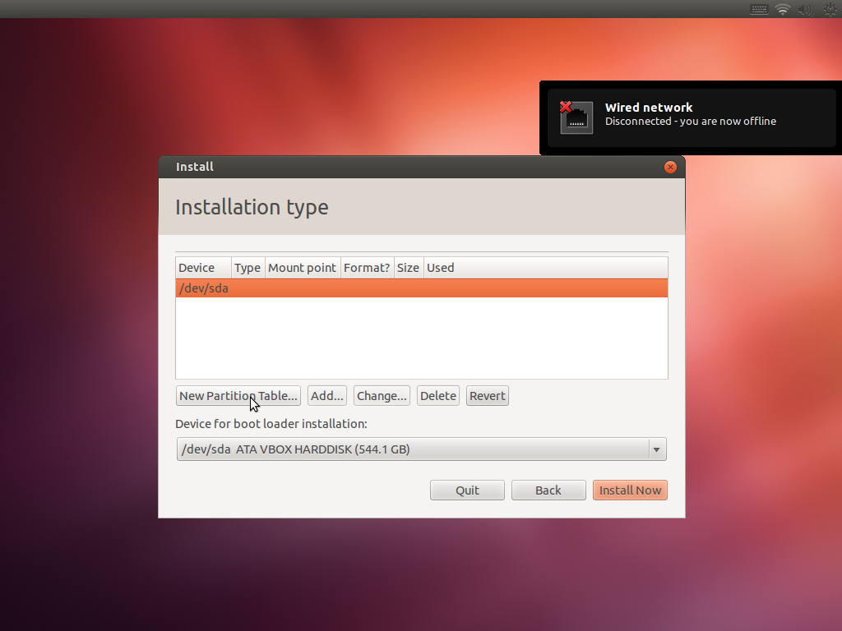

7.- Click on “Continue”
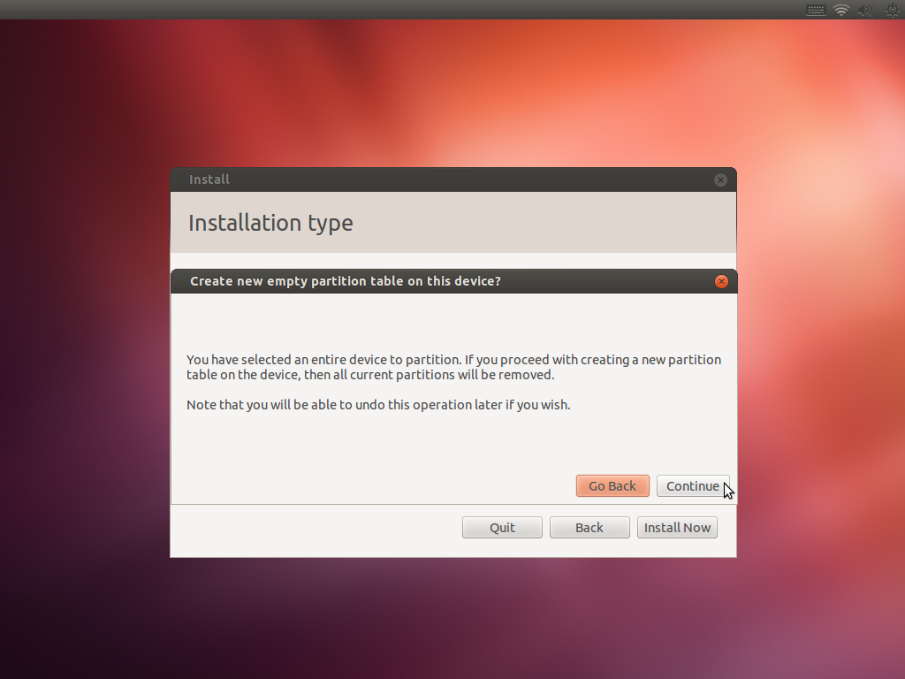

8.- Select “free space” and click on “Add…”

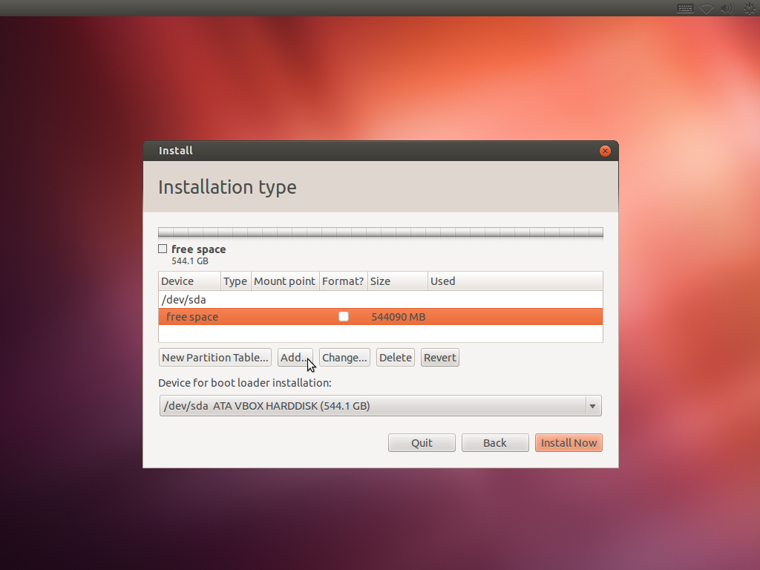

9.- On “Create a new partition” select these values.
Type for the New Partition: Primary
New partition size in Megabytes…: 500
Location for the New Partition: Beginning
Use as: Fat32 file system
Mount point: Nothing

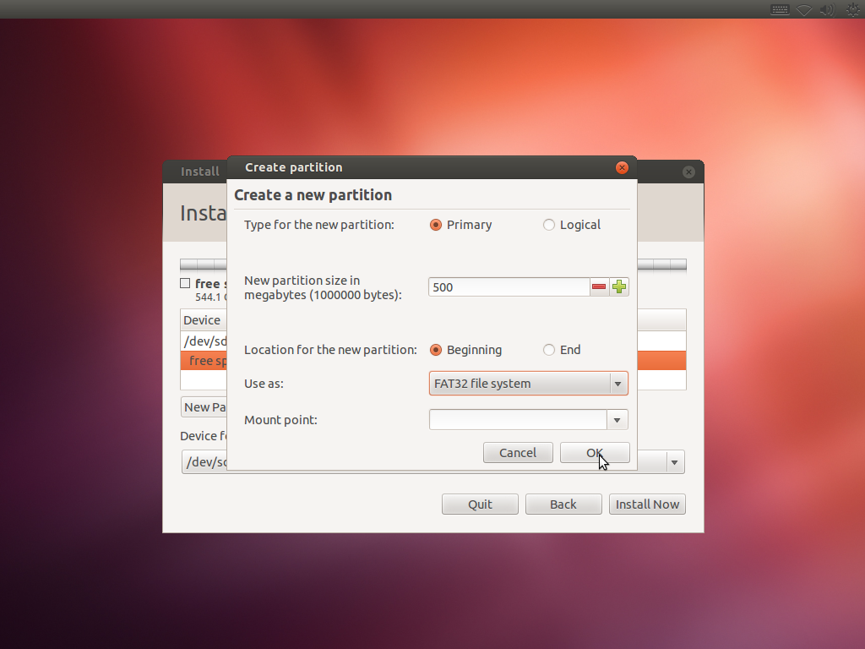

10.- Select “free space” and click on “Add…”
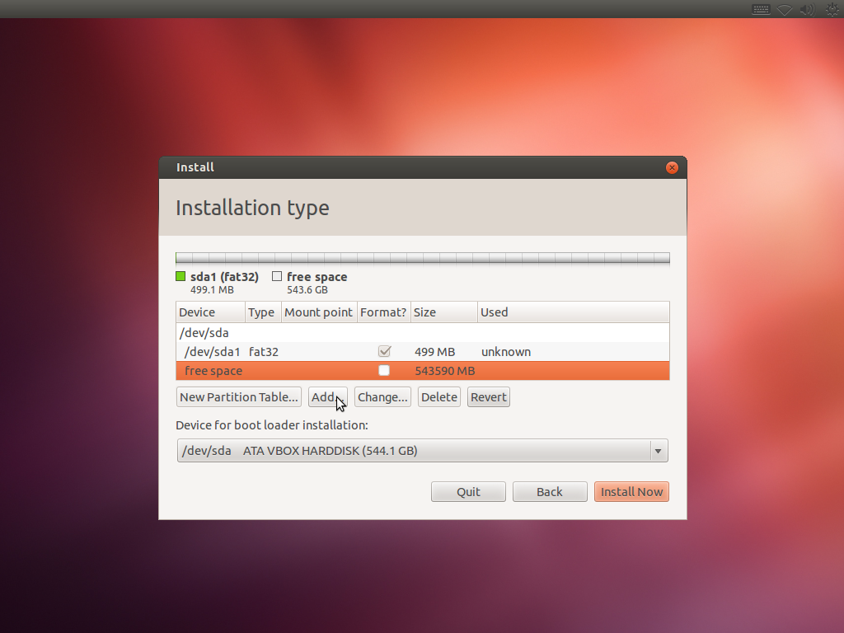

11.- On “Create a new partition” select these values.
Type for the New Partition: Primary
New partition size in Megabytes…: 5000
Location for the New Partition: Beginning
Use as: swap area
Mount point: Nothing
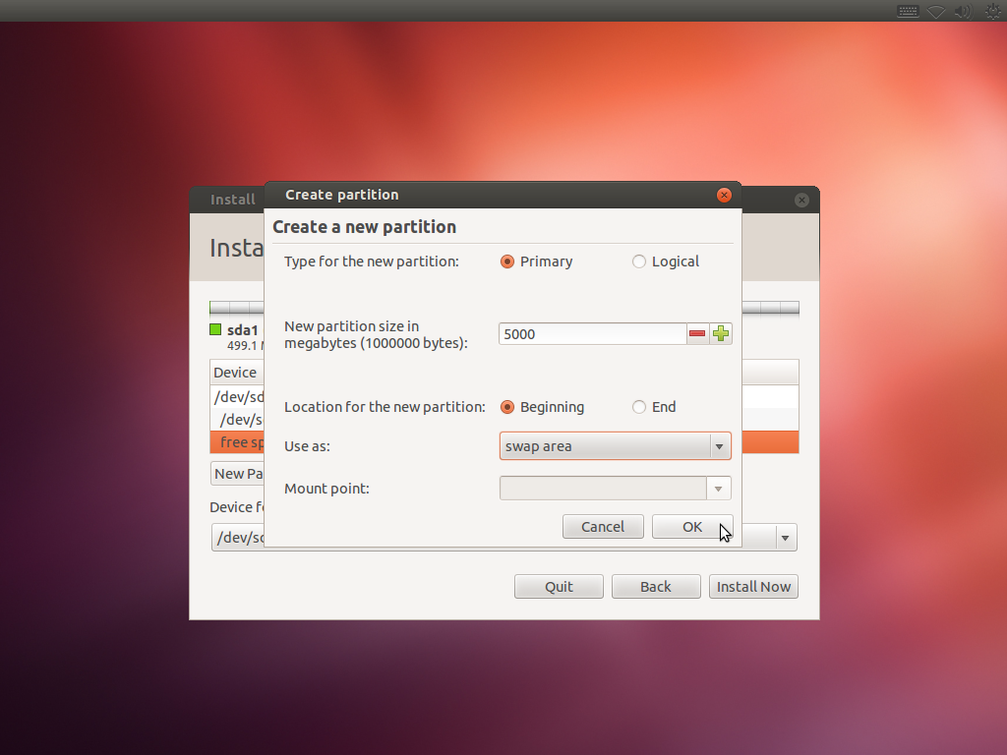

12.- Select “free space” and click on “Add…”
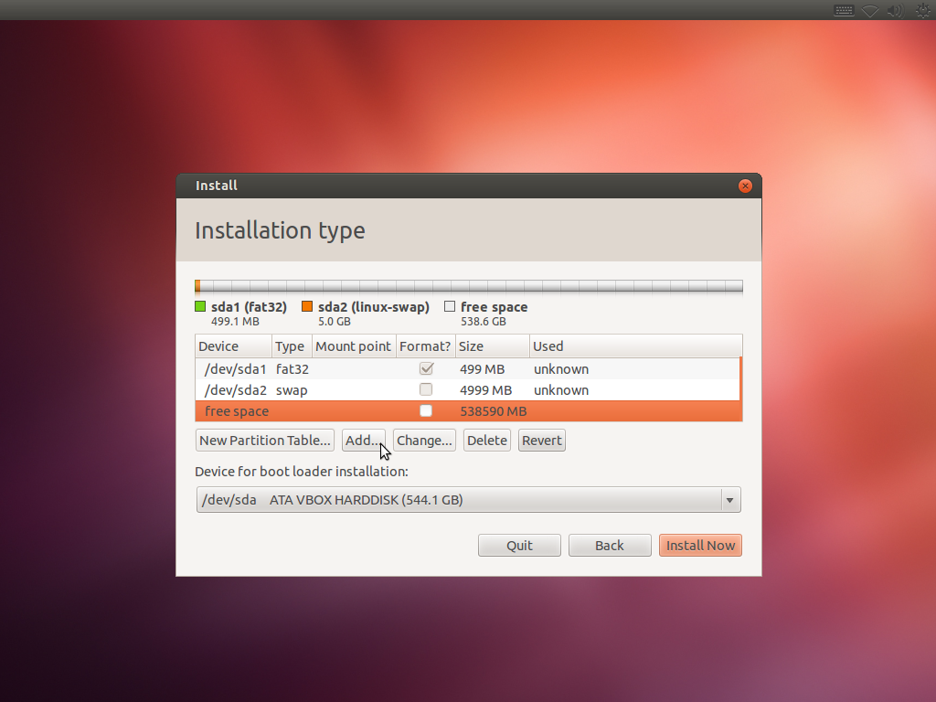

13. – On “Create a new partition” select these values.
Type for the New Partition: Primary
New partition size in Megabytes…: The rest of the free space, in this example is: 538590.
Location for the New Partition: Beginning
Use as: swap area
Mount point: /

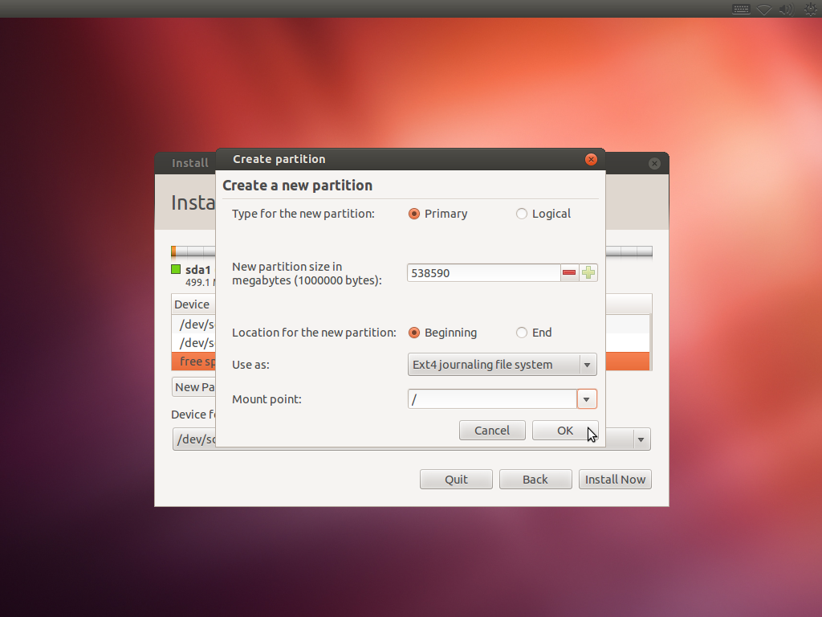

14.- Click On “Install Now”
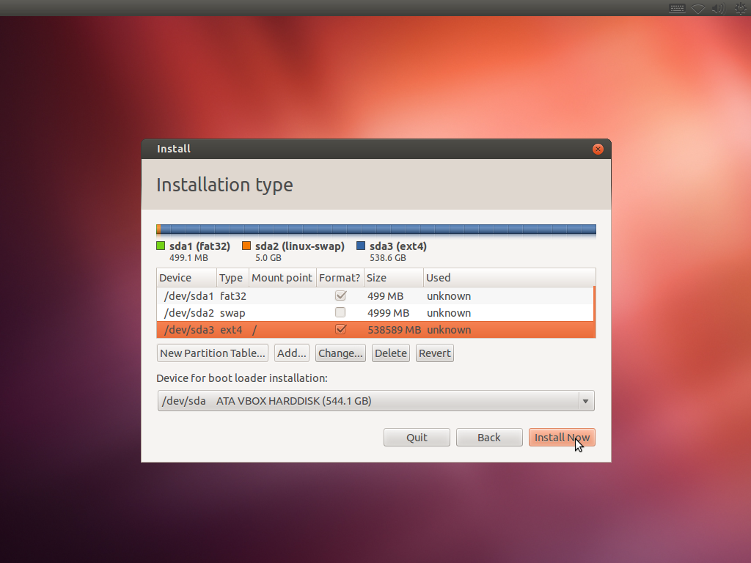

15.- Click on “Continue”
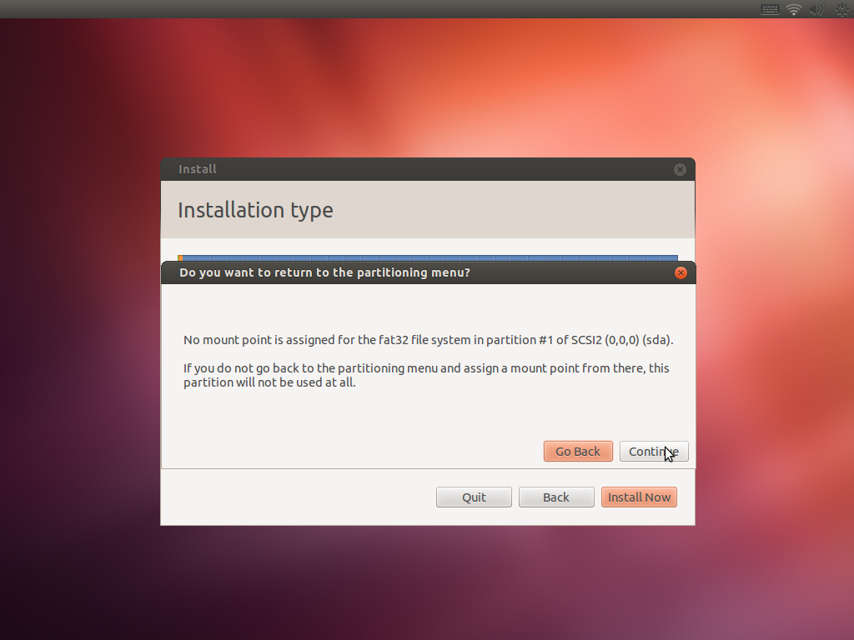

16.- Select localization and click on Continue.
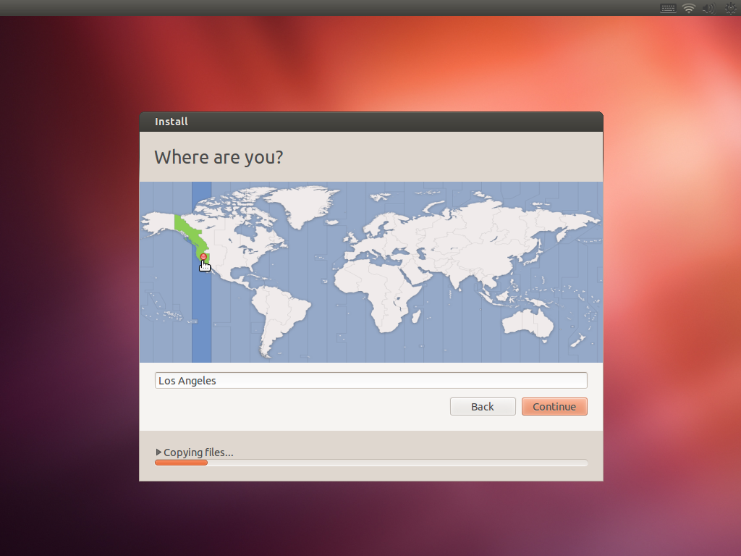

17.- Select “Keyboard Layout” and click on Continue.
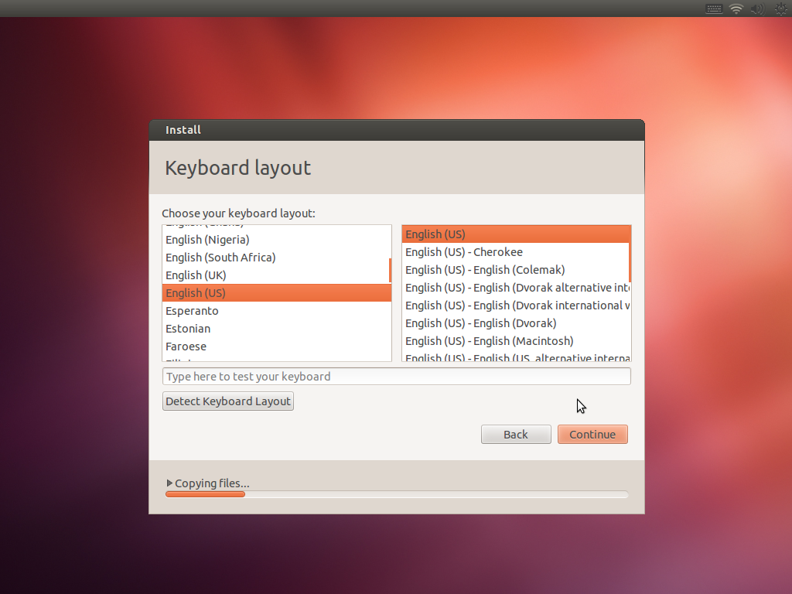

18.- Click on “Restart Now”
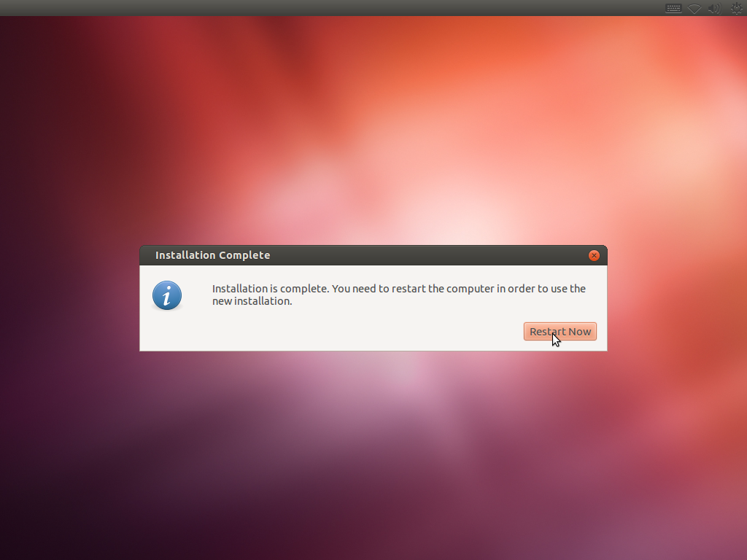

19.- Reinsert the Installation DVD and Press Enter.
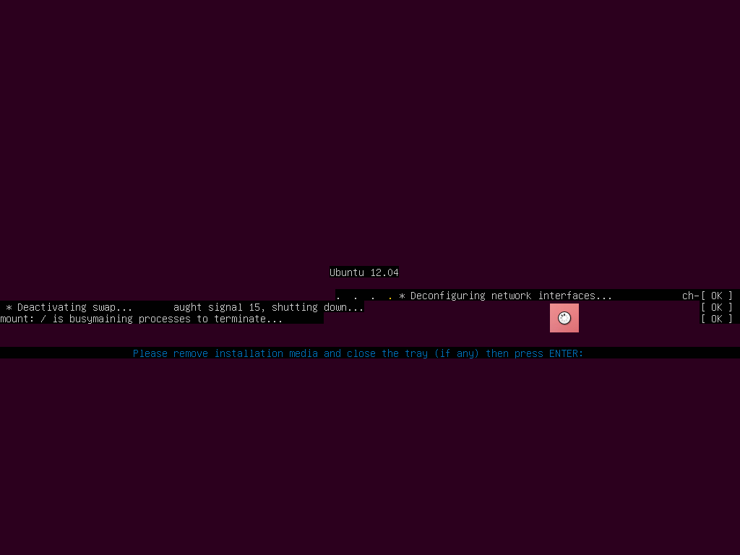

20.-When the computer reboot select “Try Ubuntu…”, and press ENTER.

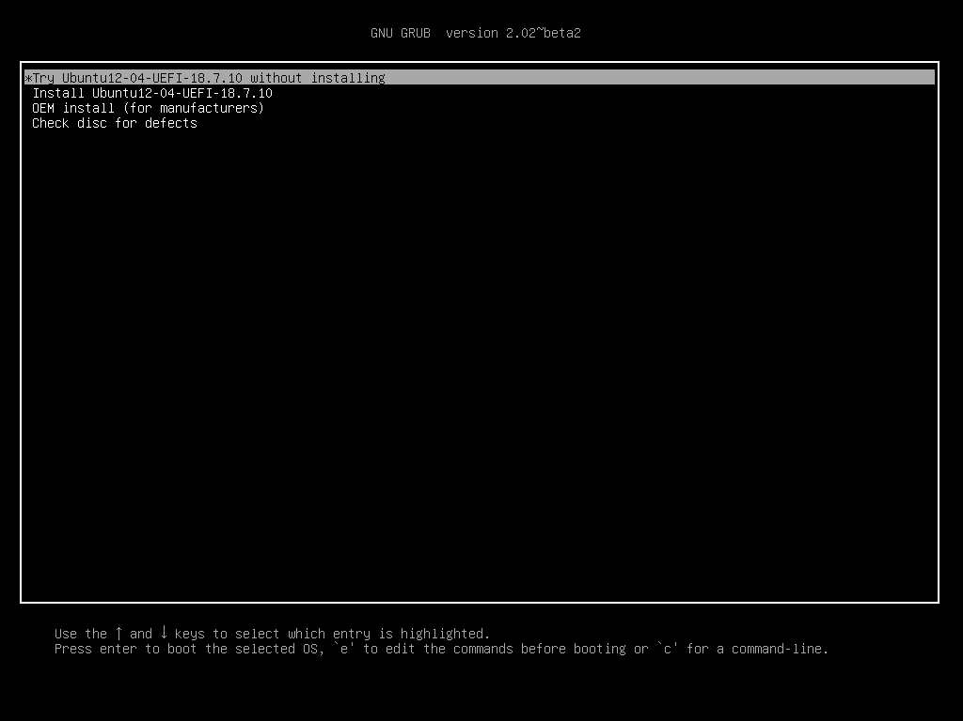

21.- Double click on “fixgrub.sh”
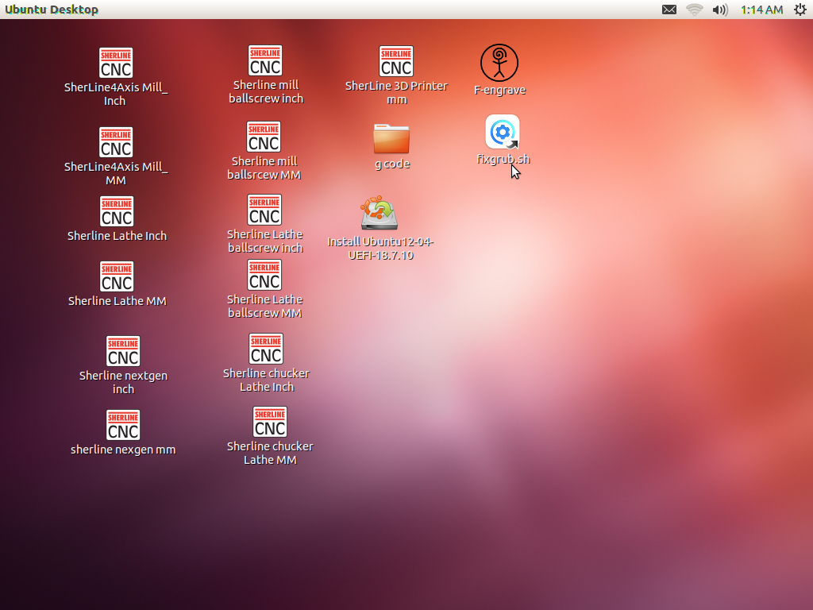

22.- click on “Run in Terminal”
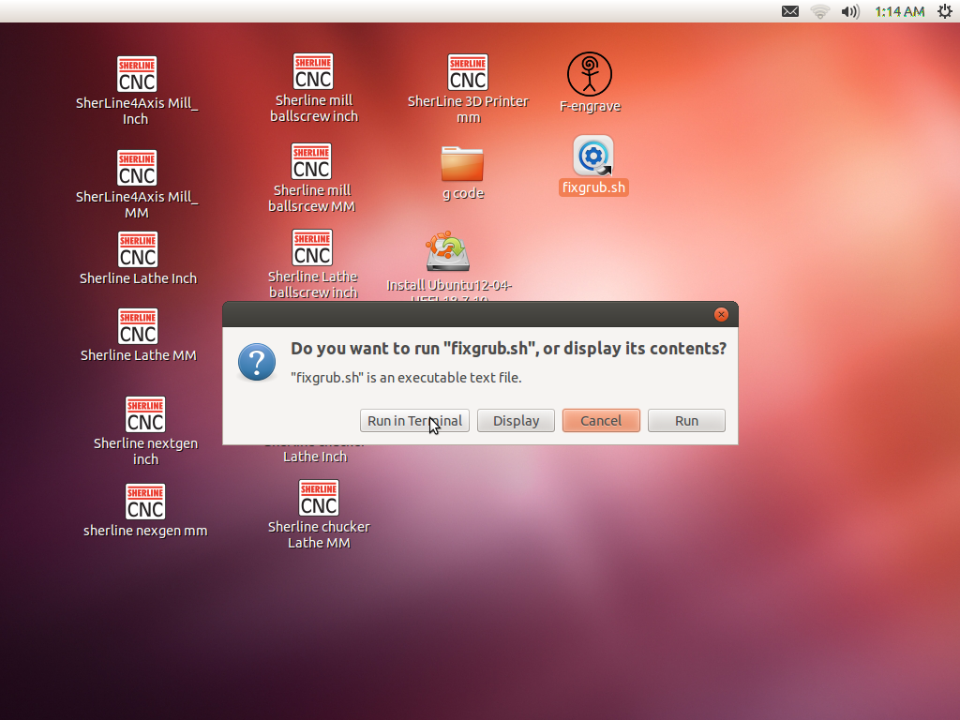

23.- Enter the password “sherline” and press ENTER
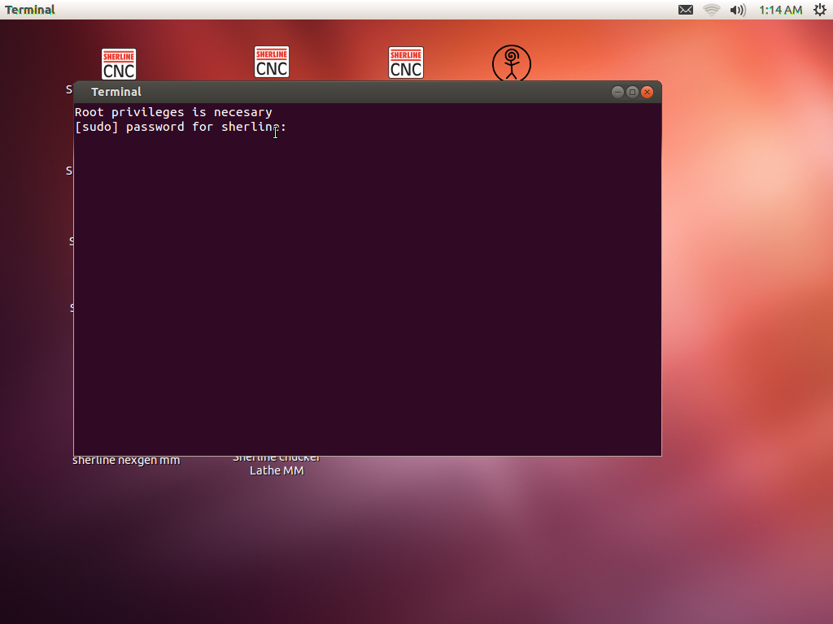

24.- Press “ENTER”
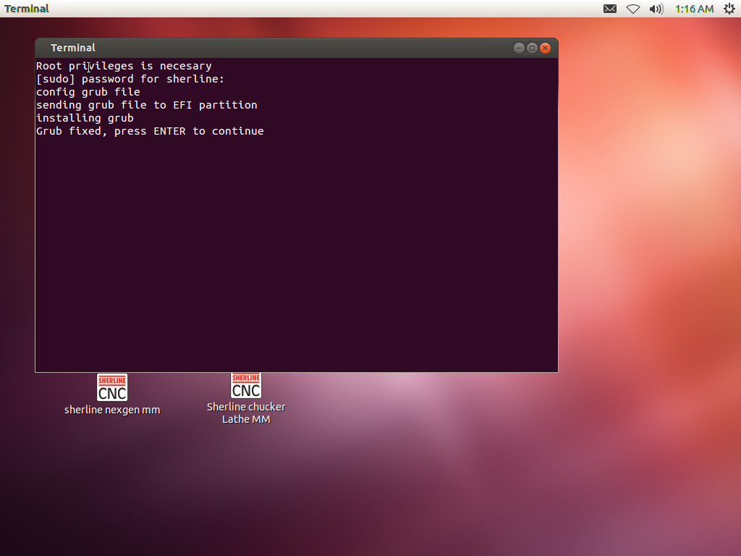

25.- Restart the computer and eject manually the Installation DVD.
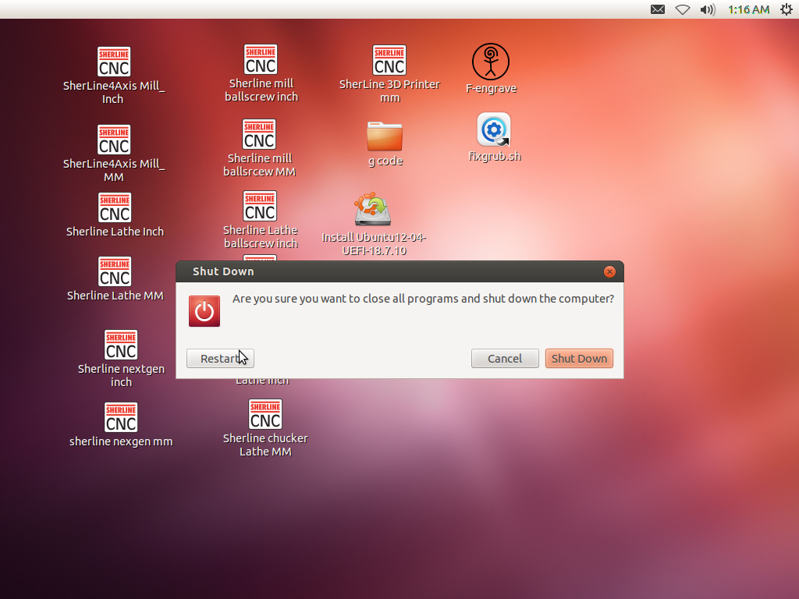

26.- If the installation was success you can see this screen after reboot, Press ENTER.

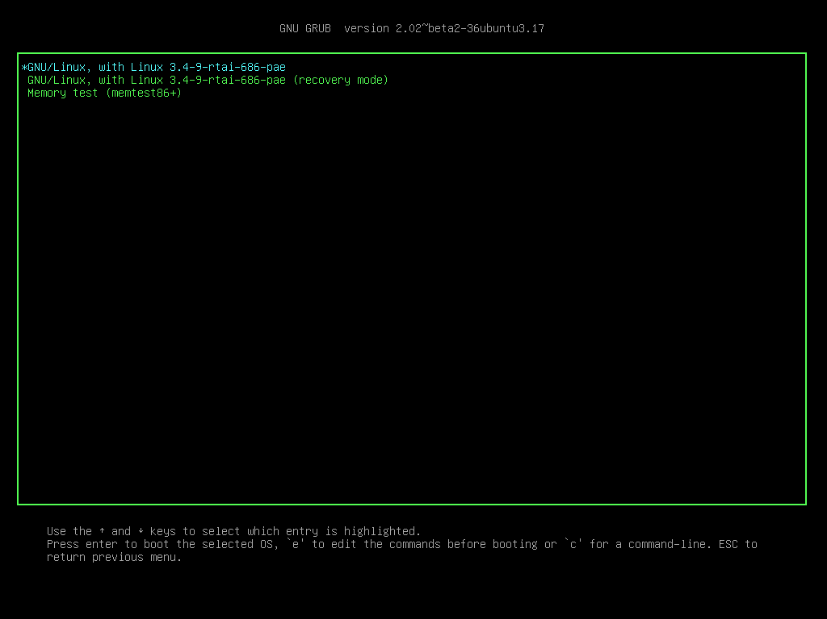

27. When the Ubuntu is loaded for first time you see this screen

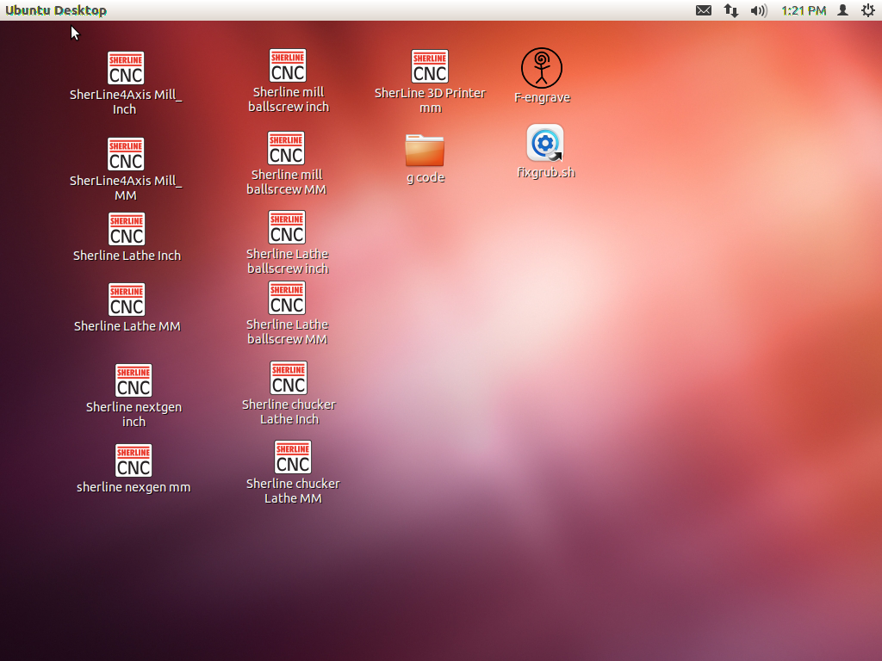

28.-Delete the file fixgrub.sh pressing DELETE key or right click on the file and click on “Move to trash”.
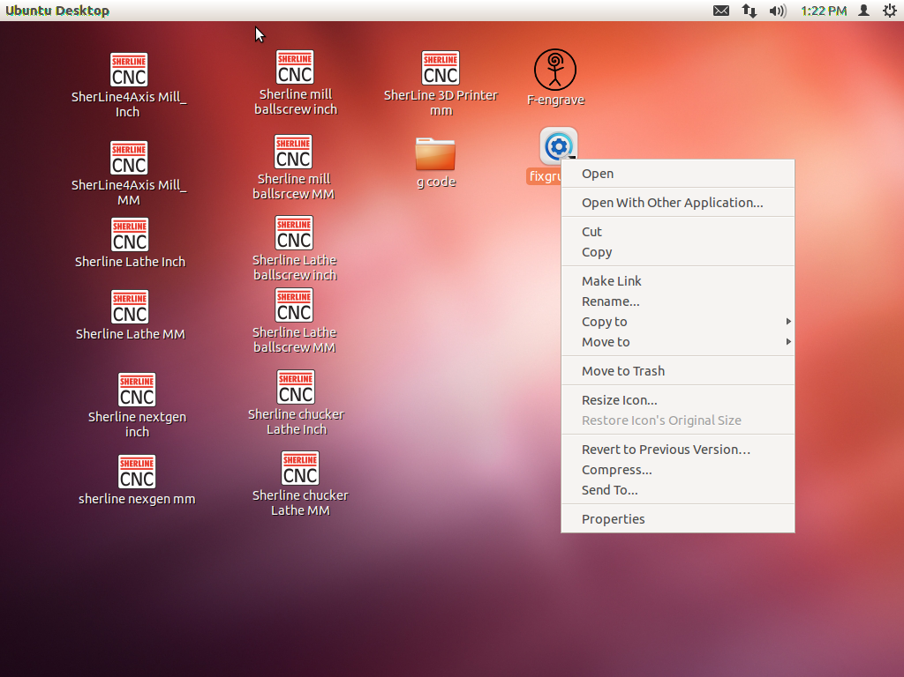

In you see these errors you need go back to the step number 20

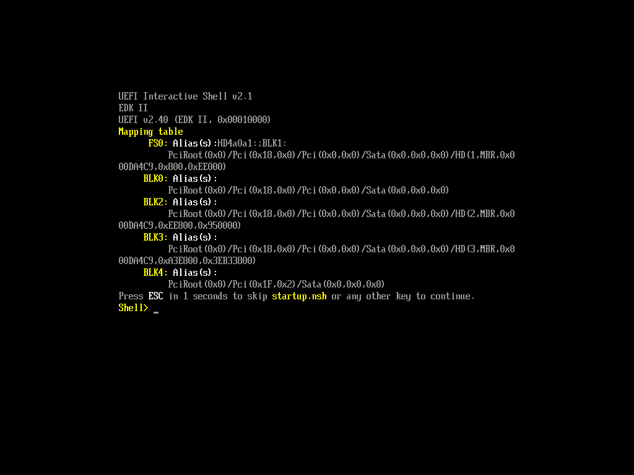

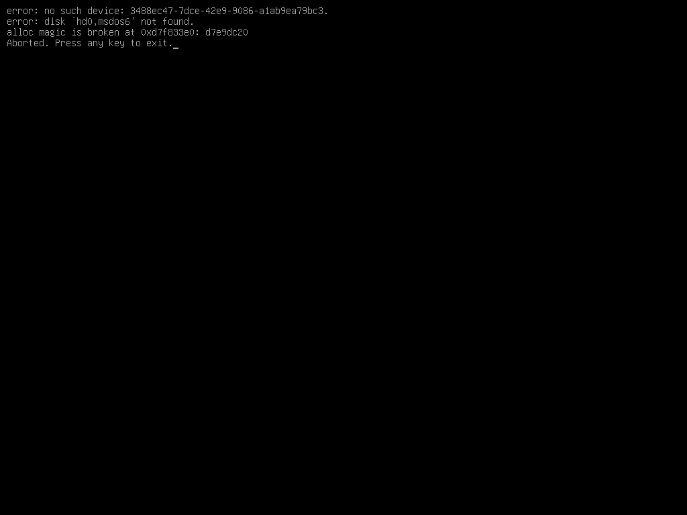

https://en.wikipedia.org/wiki/Unified_Extensible_Firmware_Interface#cite_note-ElReg1-2

