Installation on Computers with BIOS firmware
user: sherline password: sherline
1. Boot with the installation DVD.
2. Select Install - start the installer directly. See example below
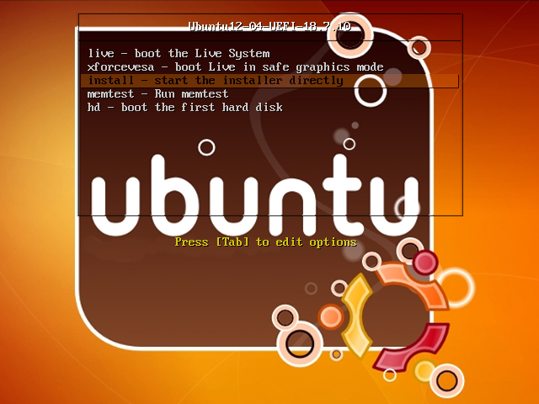

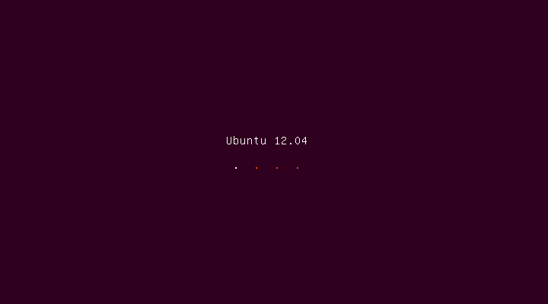
3. Select Language and Click on “Continue
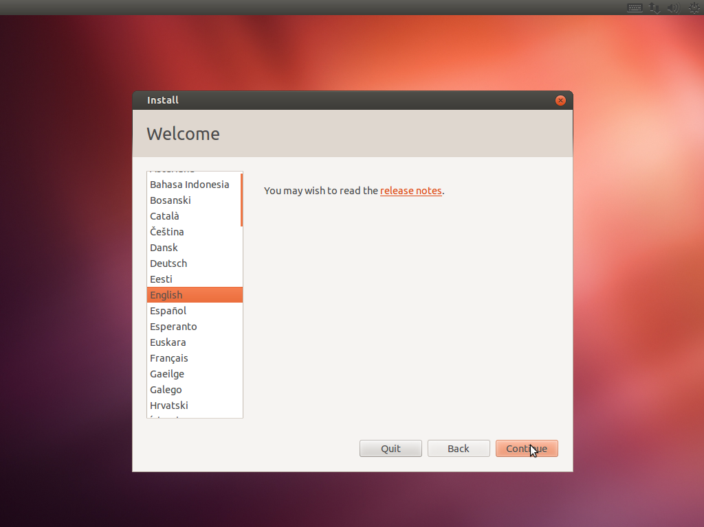
4. Click on “Continue”

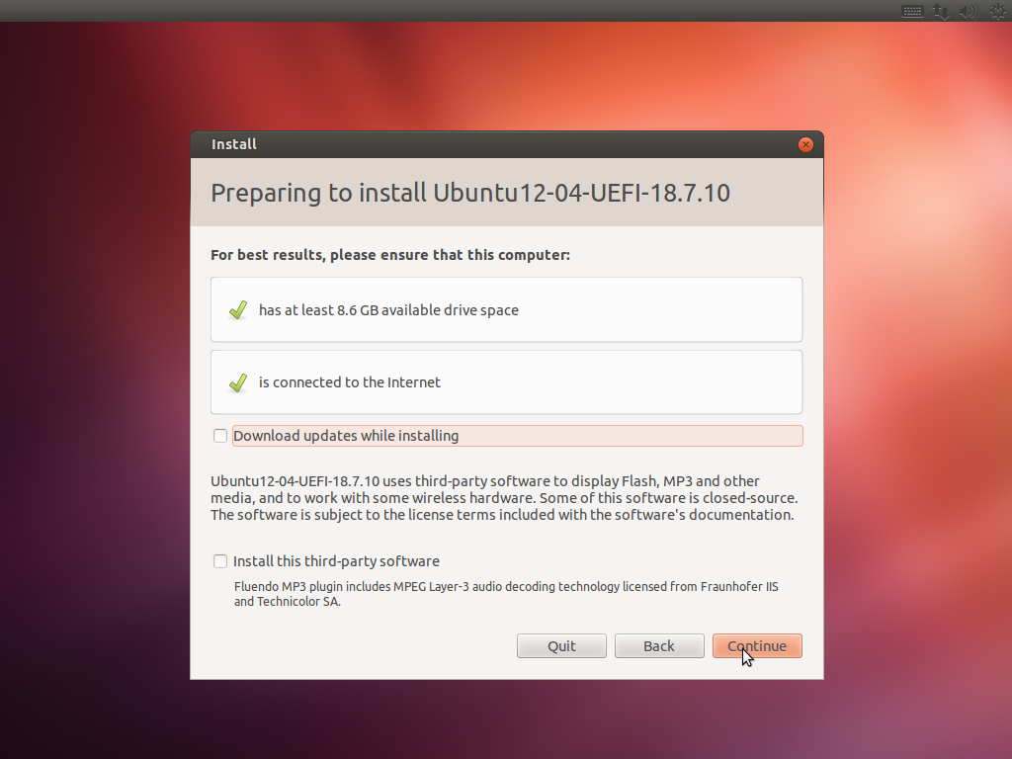

5. For installation type Select “Erase Ubuntu 12.04.5 and reinstall” and click on “Continue”.

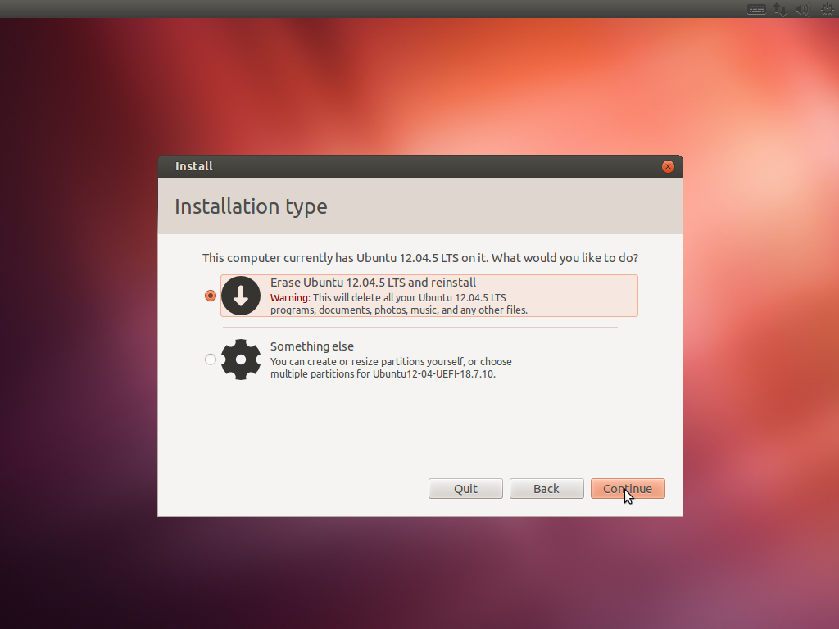

6.- Select drive and Click on “Install now”

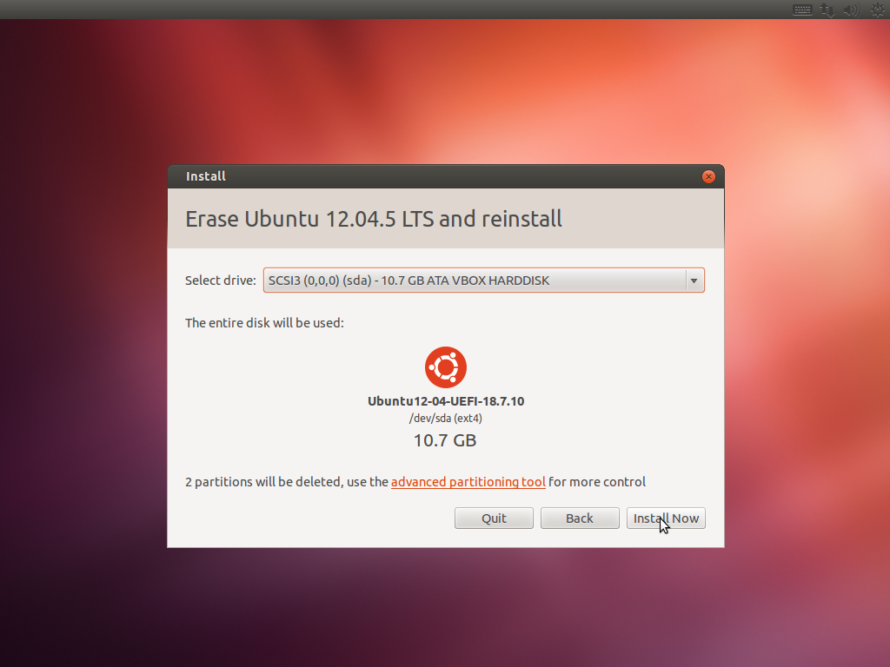

7.- Select Location and click on “Continue”.

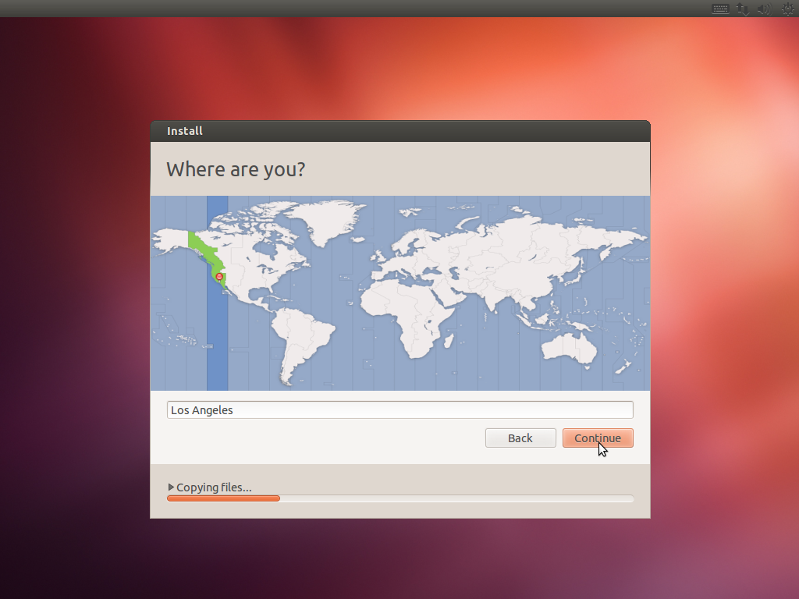

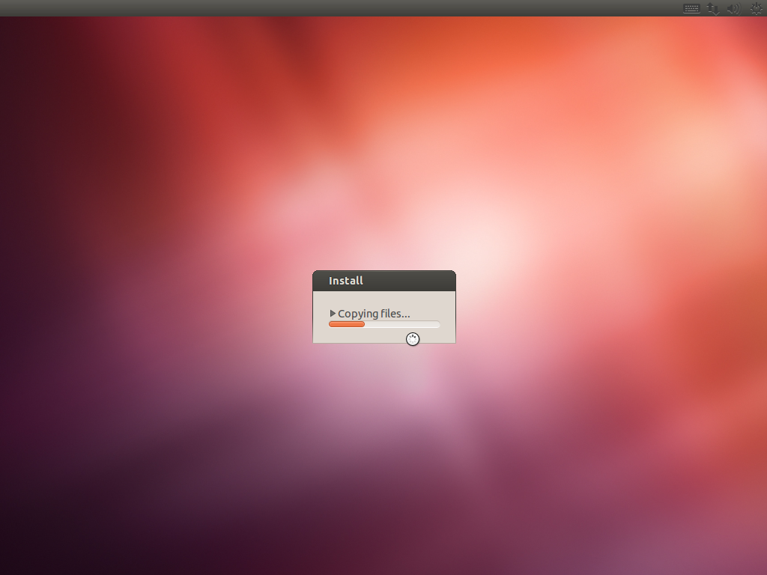

8.- Click on “Restart Now”
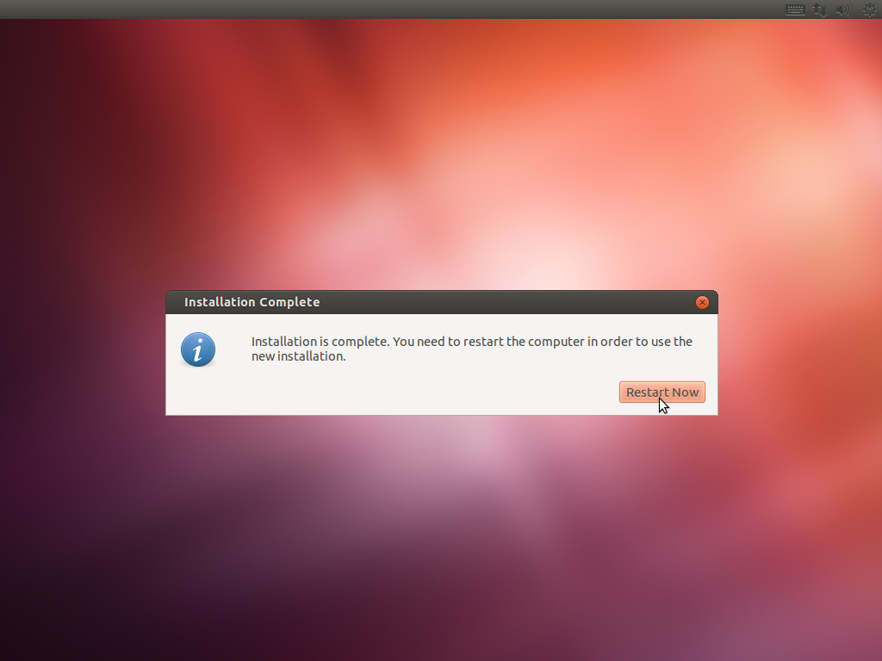
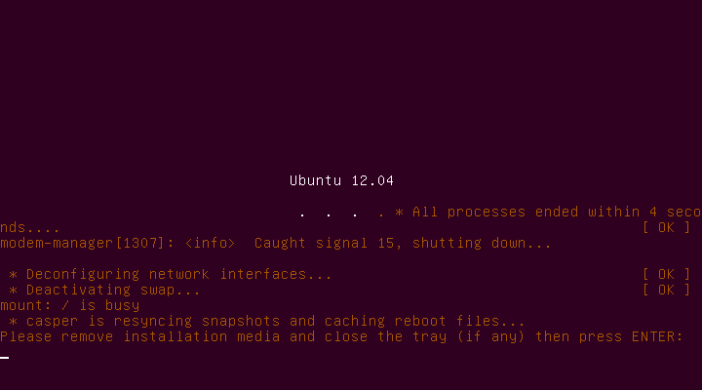
9.-When the Ubuntu is loaded for first time you see this screen.
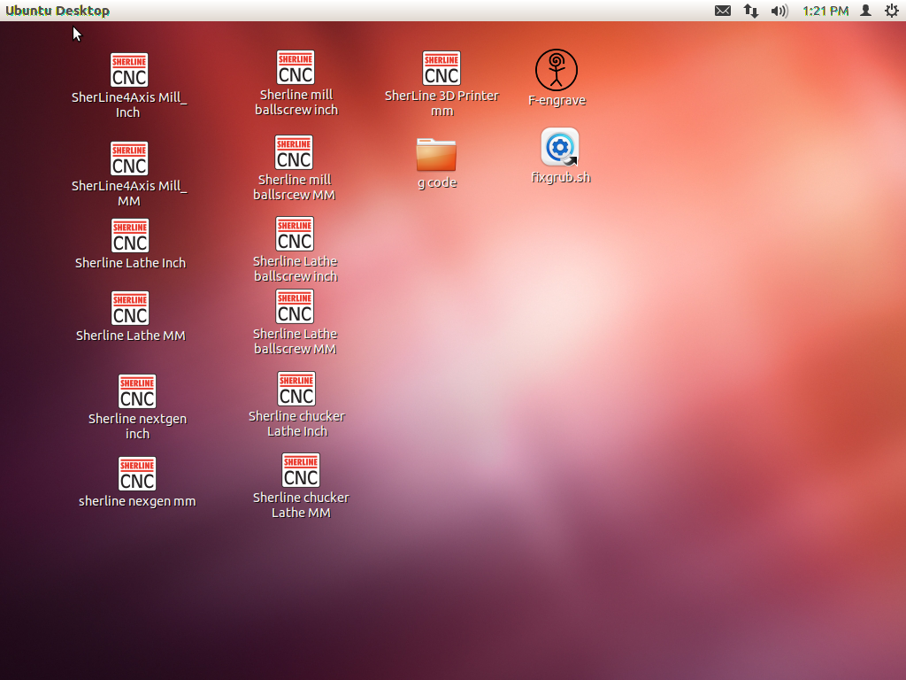

10.- Delete the file fixgrub.sh pressing DELETE key or right click on the file and click on “Move to trash”.
