Reinstallation On computers with only UEFI support.
user: sherline password: sherline
The Unified Extensible Firmware Interface (UEFI) is a specification that defines a software interface between an operating system and platform firmware. UEFI replaces the Basic Input/Output System (BIOS) firmware interface.
1.- Boot with the DVD.
2.-Select “Install Ubuntu…”
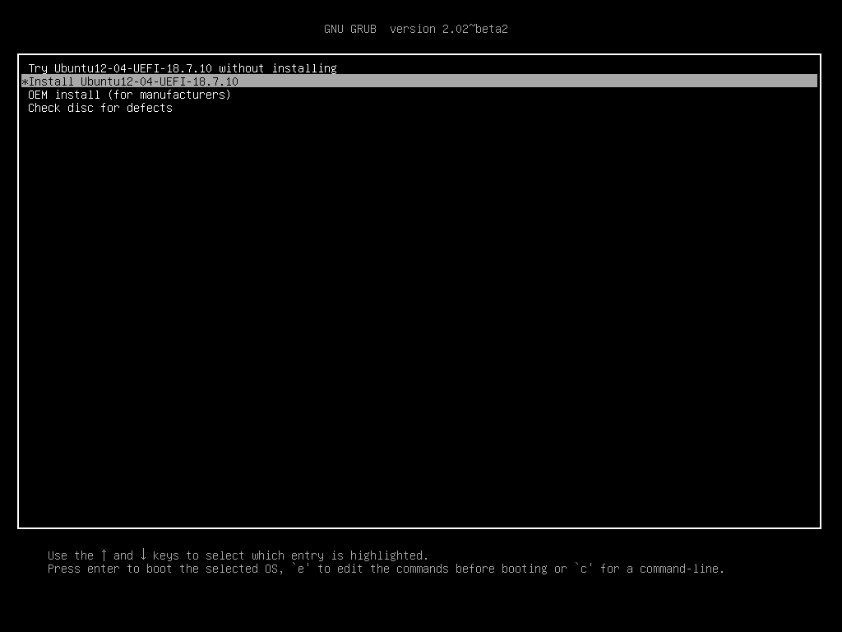

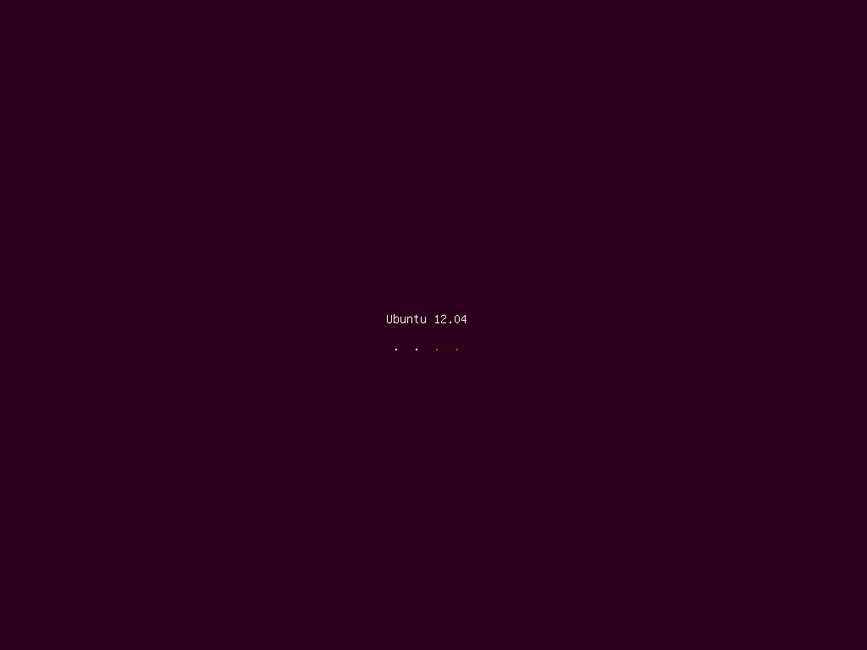
3.- Select Language.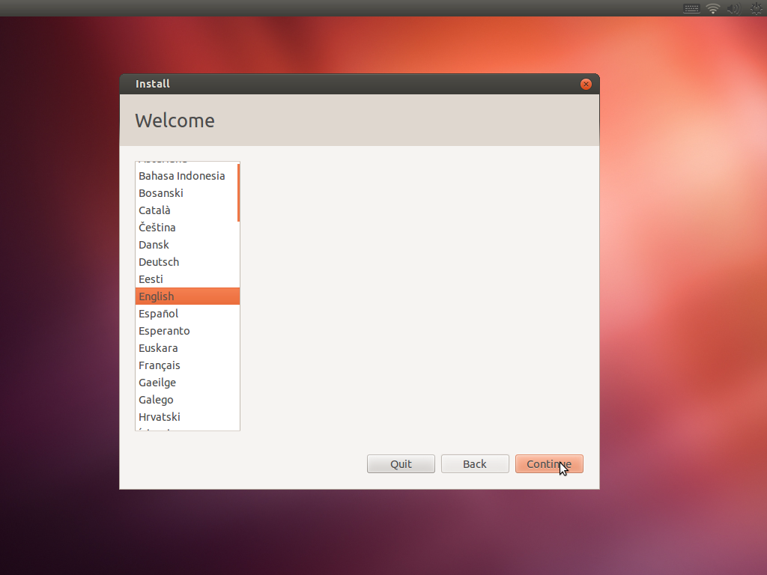

4.-Click on “Continue”
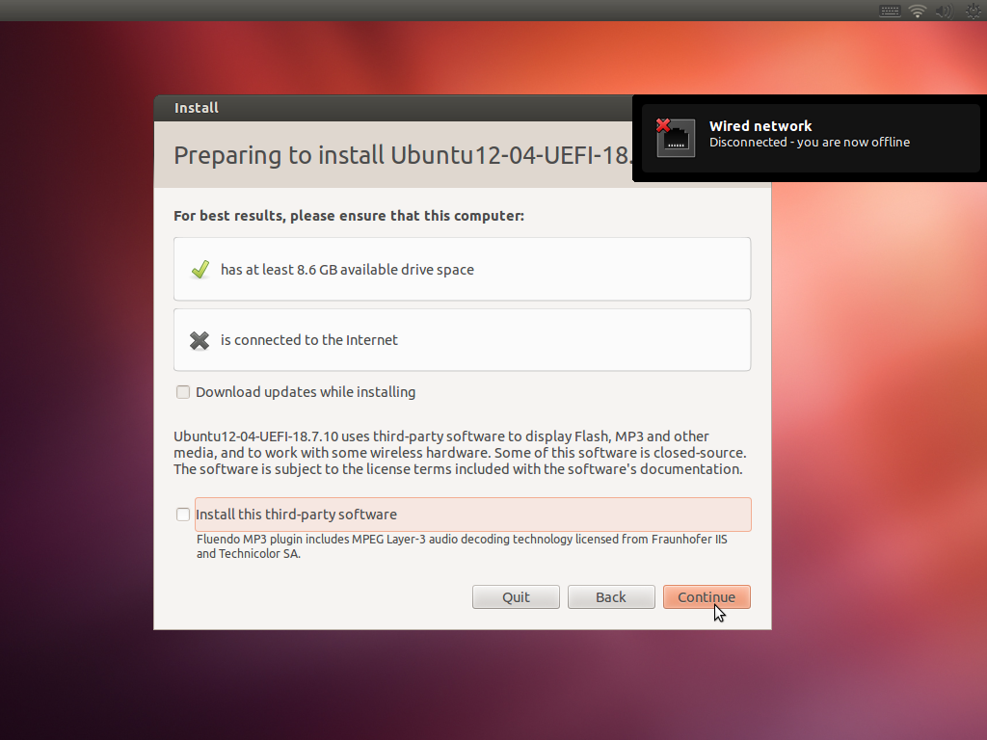

5.- Select “Something else” and click on Continue.
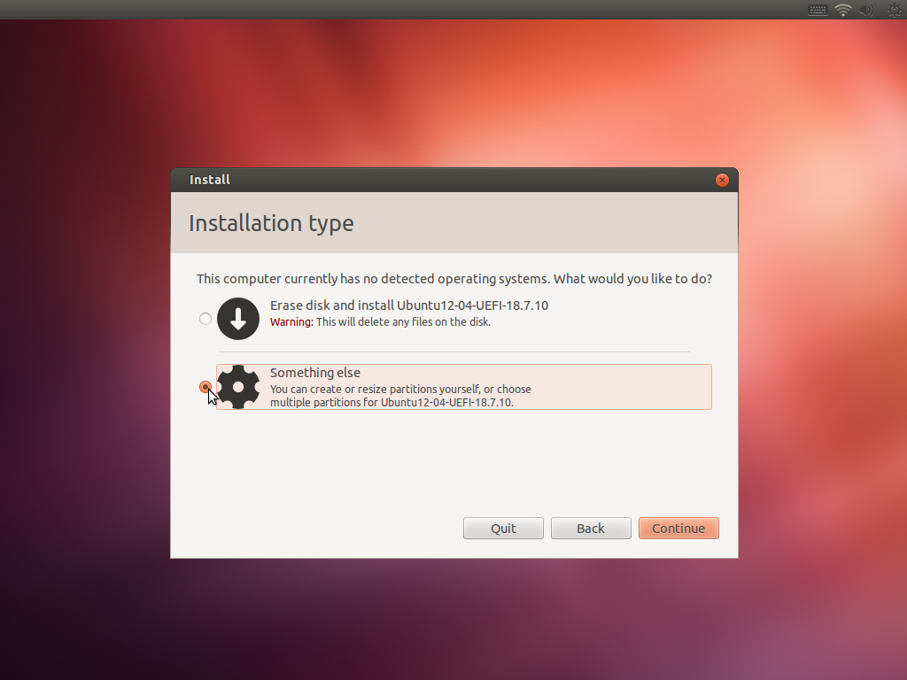

6.-Double Click on “/dev/sda3 ext4”
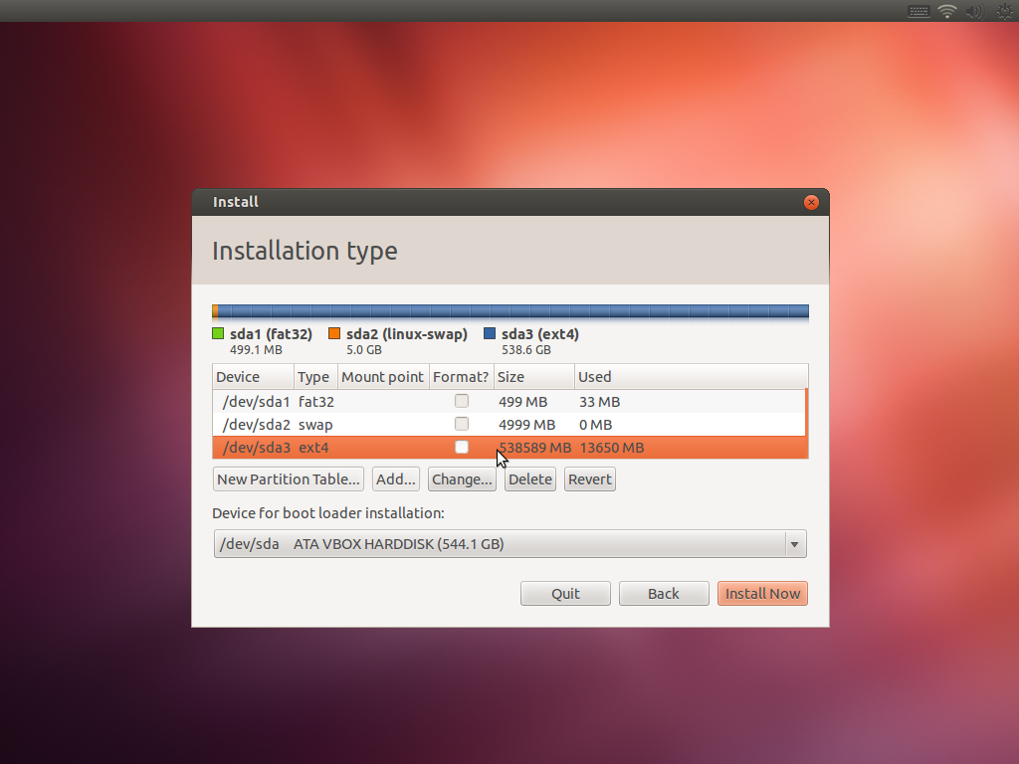

7.- On “Edit a Partition” edit these values.
New partition size in Megabytes…: untouched
Use as: Ext4 Journaling file System
Mount point: /
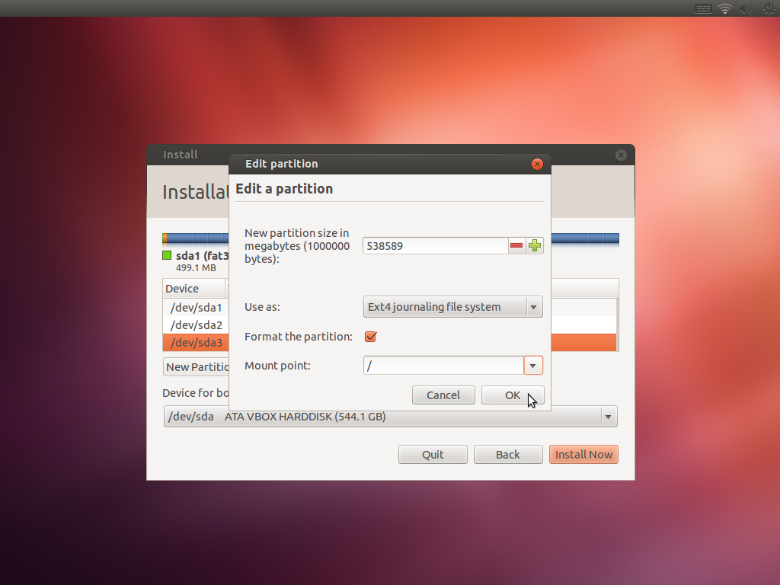

8.- Click on “Continue”
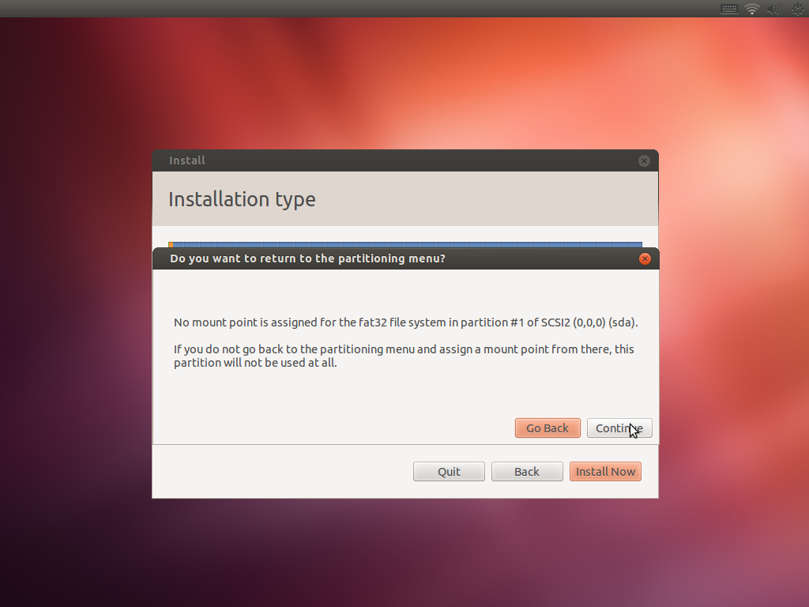

9.- Select localization and click on Continue.
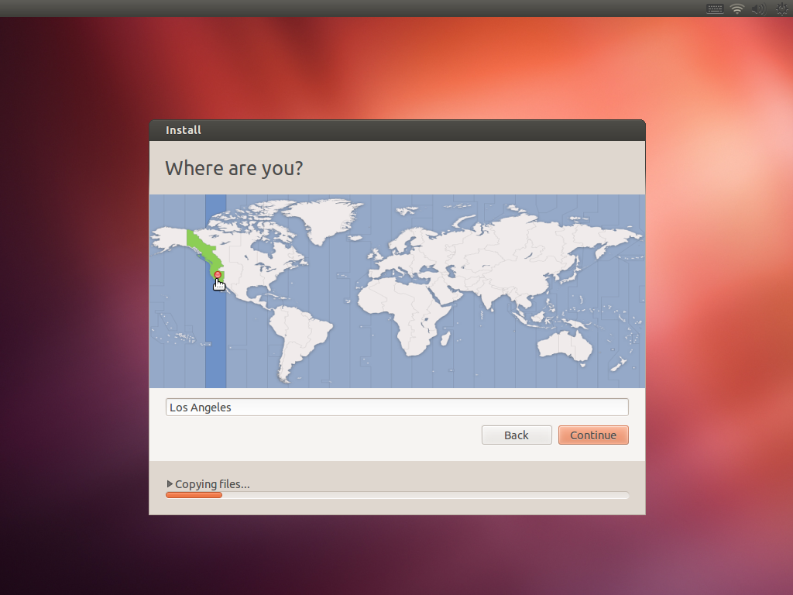

10.- Select “Keyboard Layout” and click on Continue.
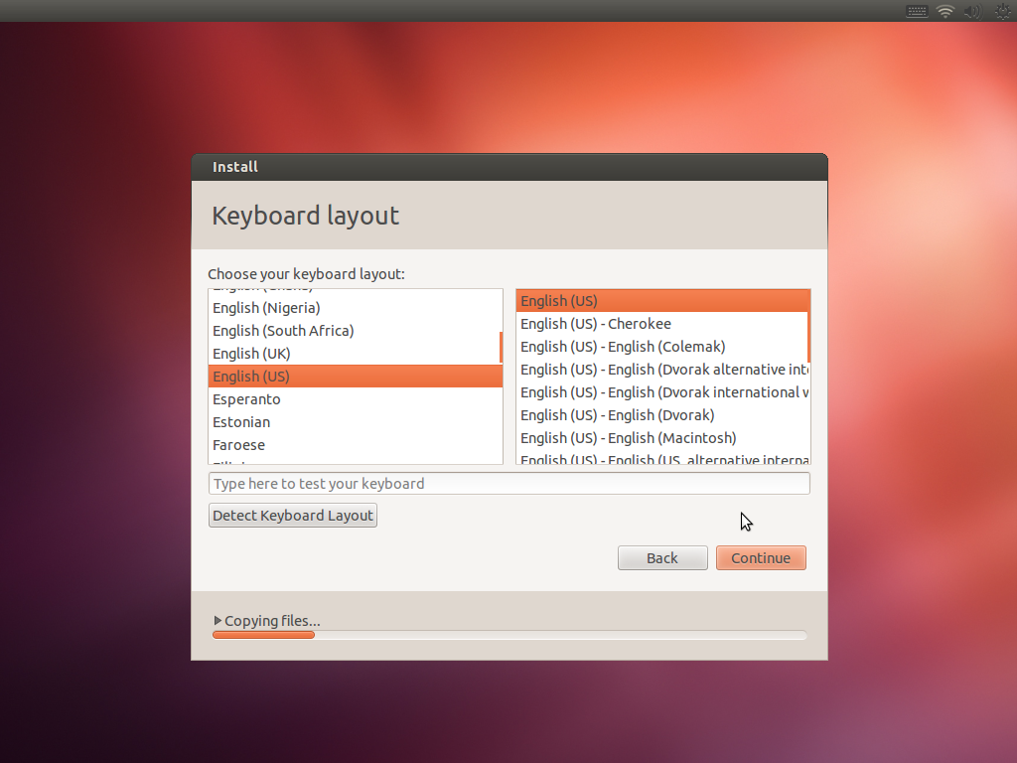

11.- Click on “Restart Now”
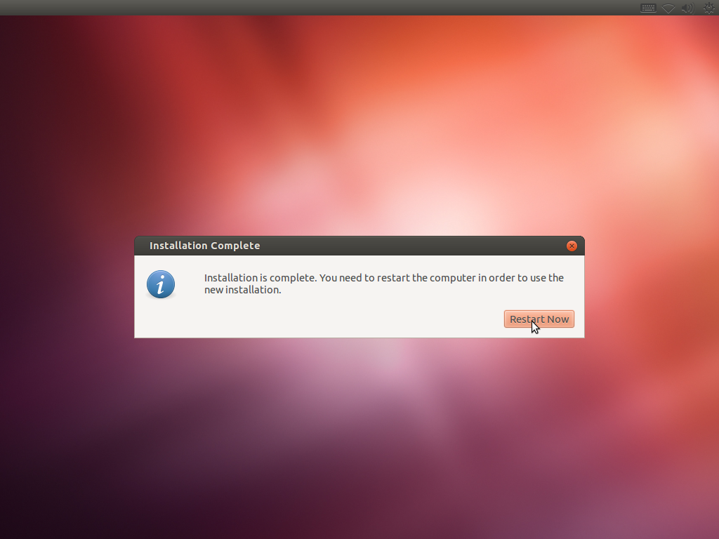

12.- Press Enter
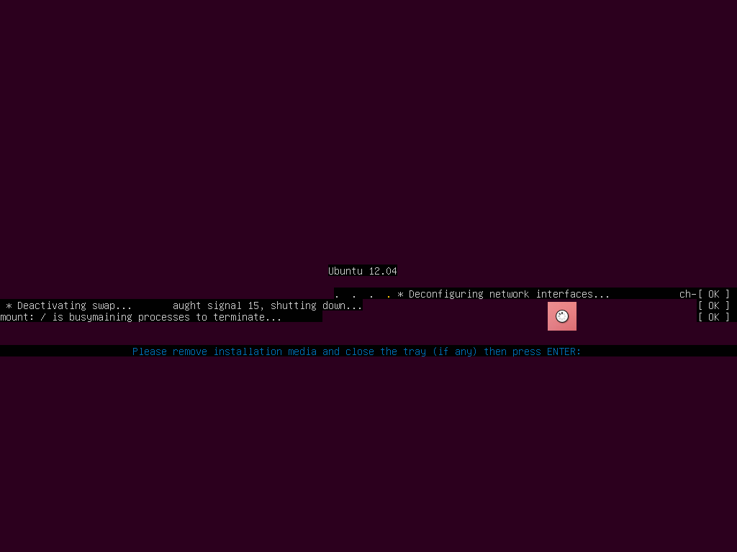

13.- Reinsert the Installation DVD, select “Try Ubuntu…”, and press ENTER.

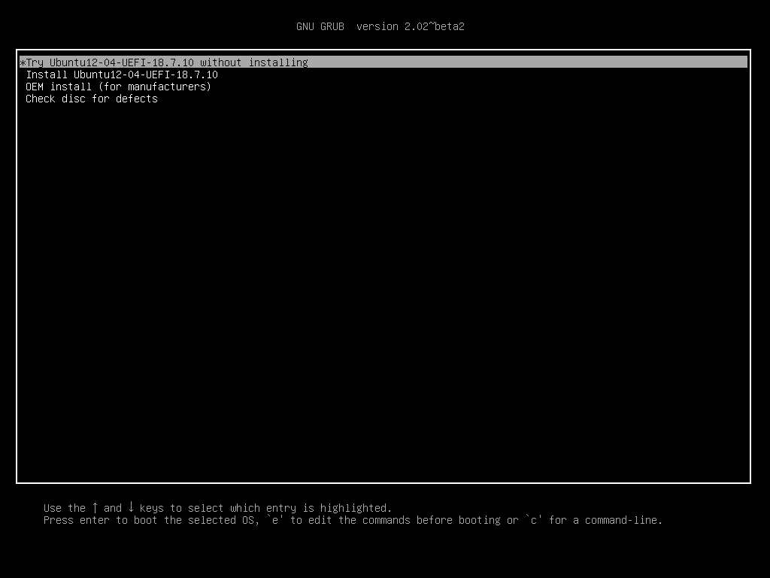

14.- Double click on “fixgrub.sh”
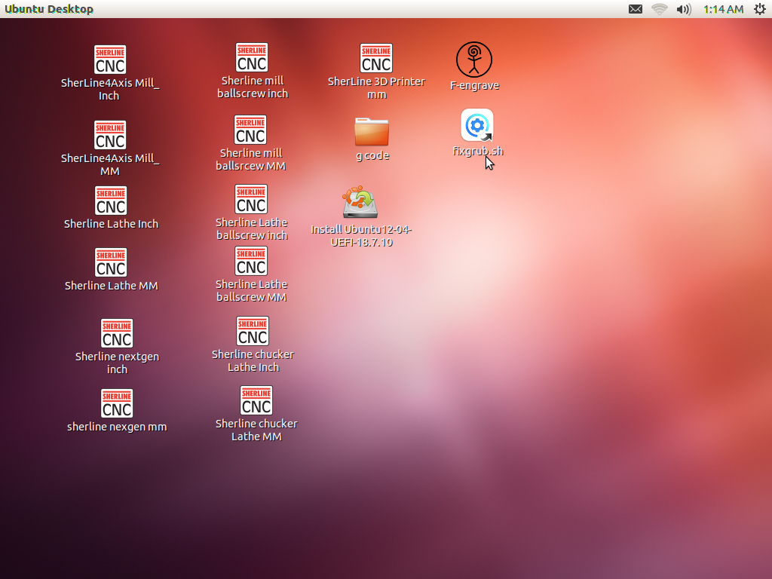

15.- click on “Run in Terminal”
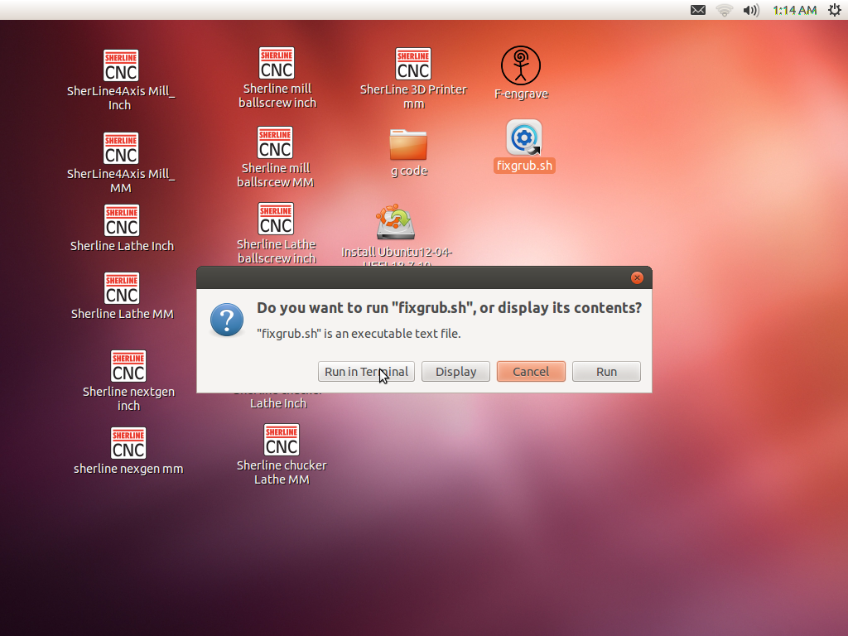

16.- enter the password “sherline” and press ENTER
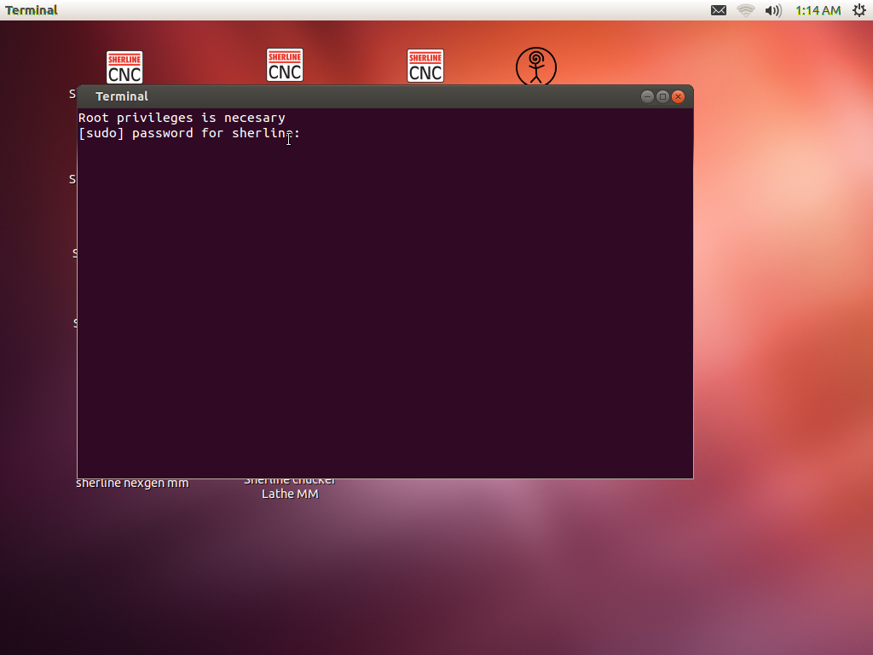

17.- Press “ENTER”
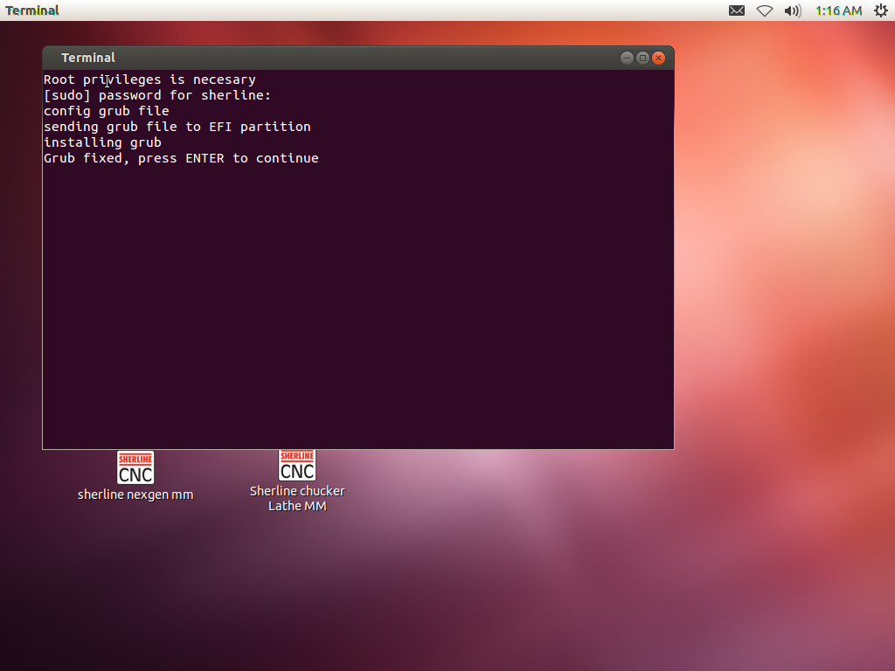

18.- Restart the computer and eject manually the Installation DVD.
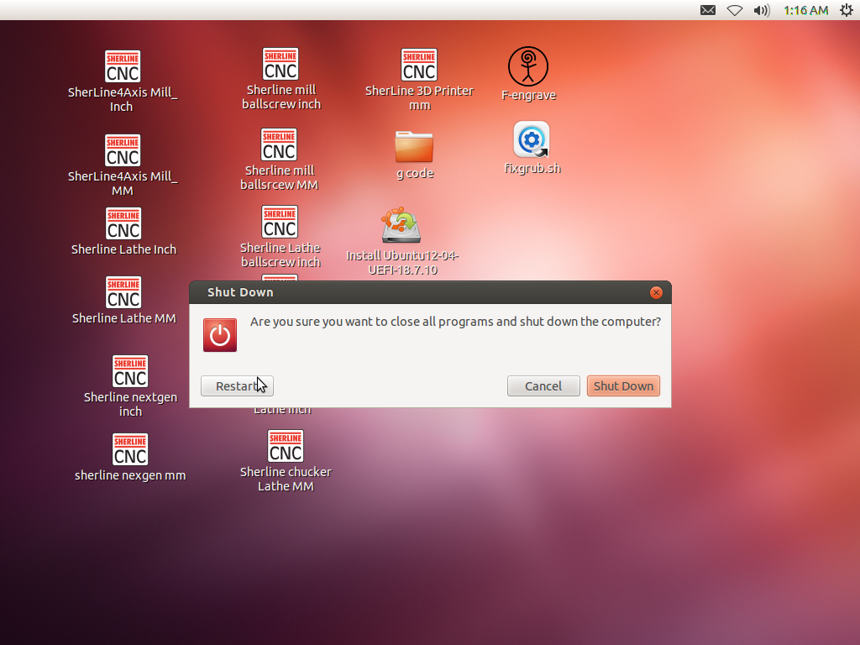

19.- If the installation was success you can see this screen after reboot.

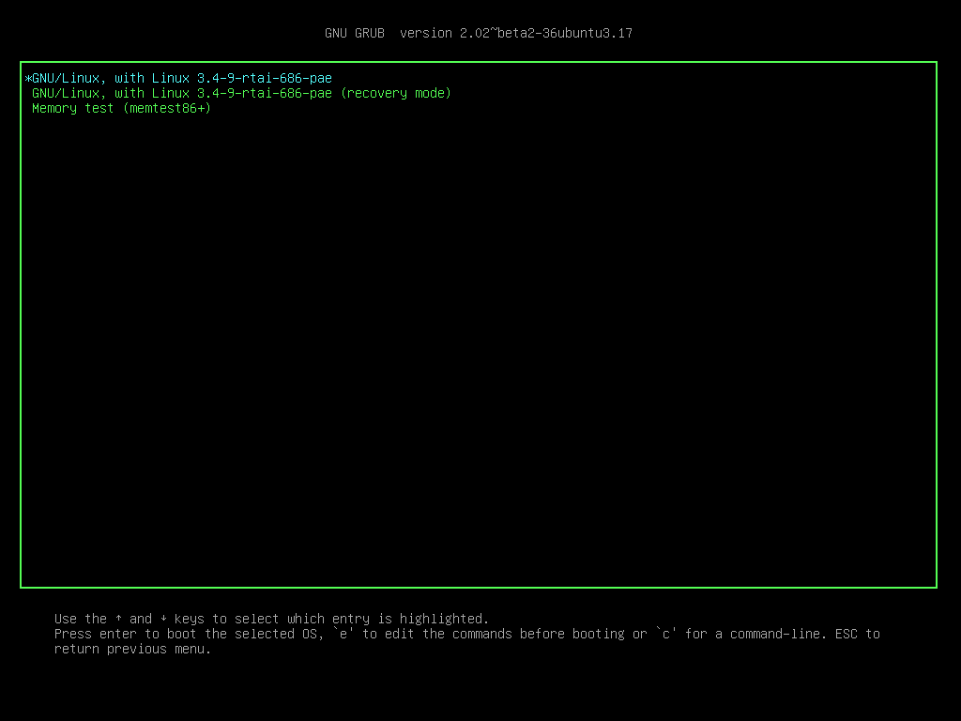

20.- When the Ubuntu is loaded for first time you see this screen

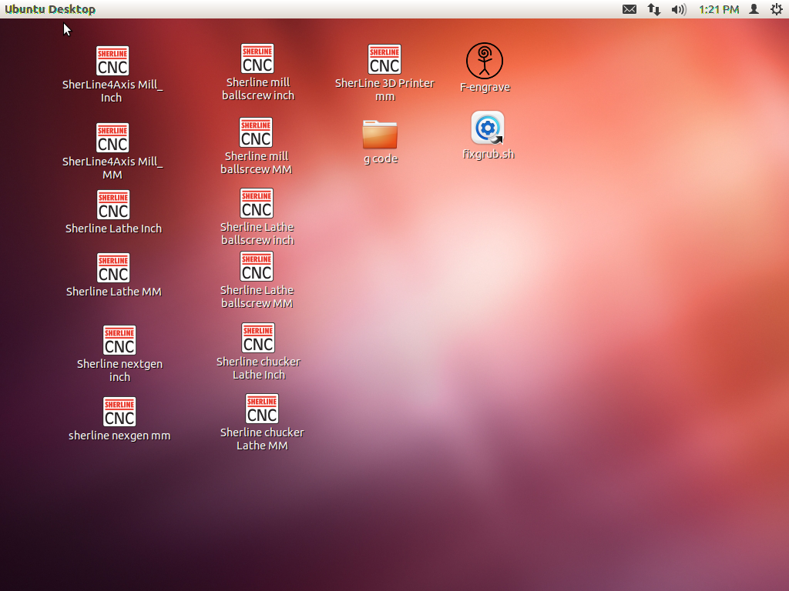

21.- Delete the file fixgrub.sh pressing DELETE key or right click on the file and click on “Move to trash”.
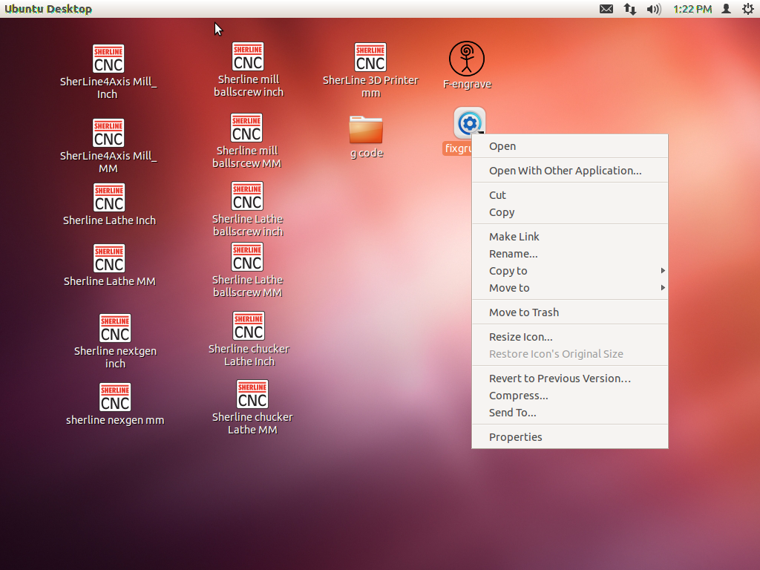

In you see these errors you need go back to the step number 13

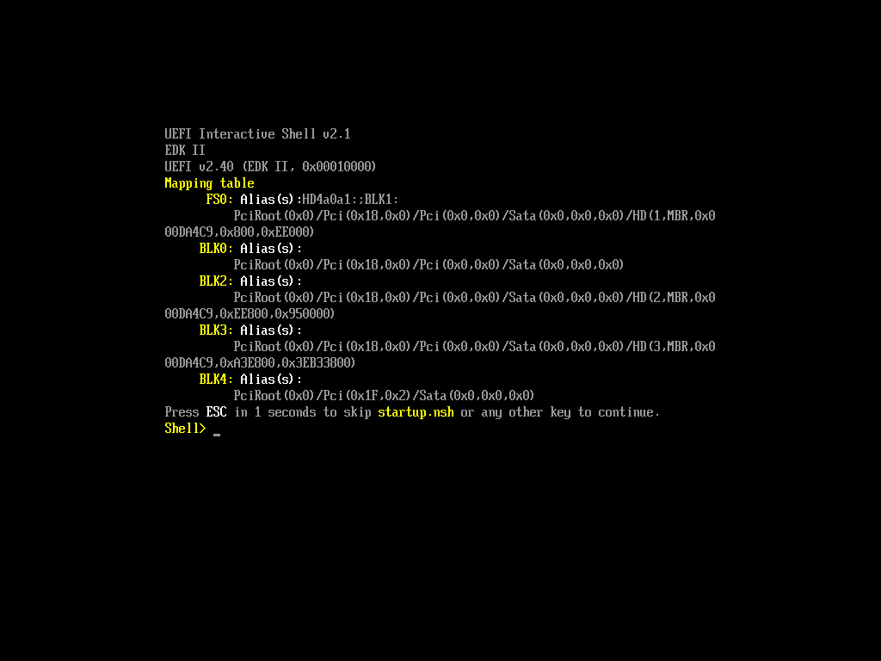

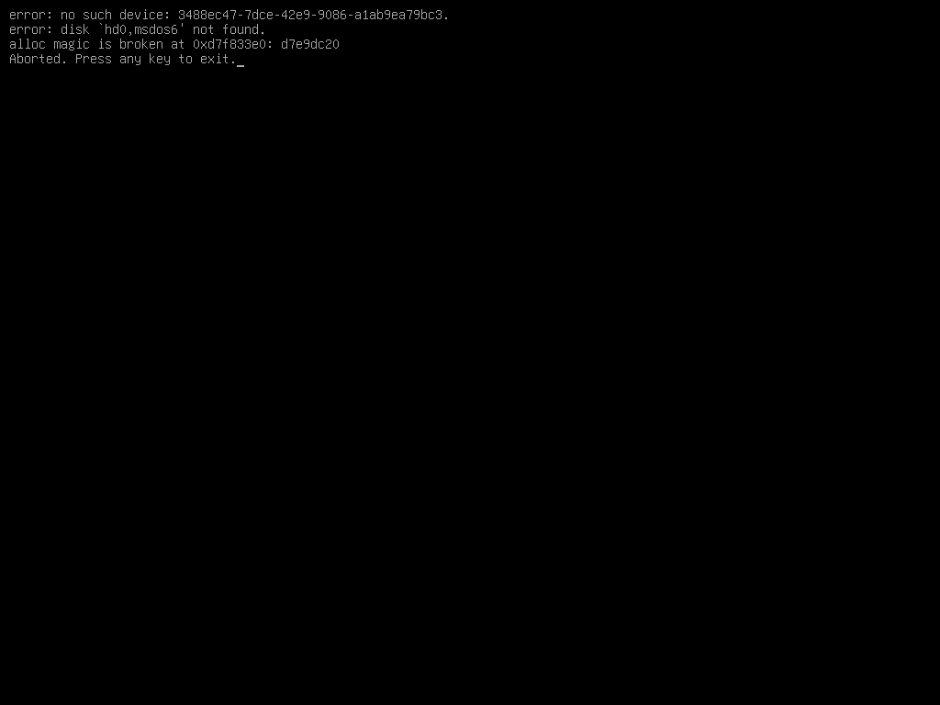

https://en.wikipedia.org/wiki/Unified_Extensible_Firmware_Interface#cite_note-ElReg1-2

